Sl. No. | Name (as appears in Taxila) | ID NO | Contribution
1 | RANGANATHA S | 2024da04087 | 100%
2 | BANDARU HAREESHA | 2024da04089 | 100%
3 | SAMARTH MOHANRAO KULKARNI | 2024da04090 | 100%

1) Create a collection named accidents in your mongodb database and import Dataset1.csv file into it using the mongoimport command. Include the database creation and mongo import command in your answer.
Command:
mongosh
use road_accident_analysis
db
exit
mongoimport --db road_accident_analysis --collection accidents --type csv --headerline --file Dataset1.csv
Output:
2) Find the total number of documents in the accidents collection.
Command:
mongosh
use road_accident_analysis
show collections
db.accidents.countDocuments()
exit
Output:
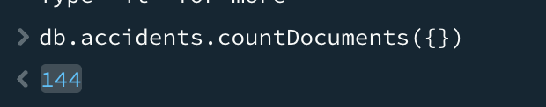
3) Create another database collection. Replace State column ID with _id and import the modified CSV file into this collection. Include the database creation and mongoimport command in your answer. Find the total number of documents in the newly created collection. If there is a difference in the total counts of documents in the results of Question 2 and 3, explain the reason for it.
Command:
mongosh
use myDatabase2
db
exit
mongoimport --db myDatabase2 --collection accidents_new --type csv --headerline --file Dataset2.csv
mongosh
use myDatabase2
show collections
db.accidents_new.countDocuments()
exit
Output:
Reason:
- In Question 2, when we imported the CSV with the State column, MongoDB automatically generated a unique _id for each row.
- In Question 3, we replaced State with _id. MongoDB enforces _id to be unique.
- If the CSV file had duplicate State IDs, then during import those duplicates would be rejected because MongoDB does not allow multiple documents with the same _id.
- Therefore, the total count in accidents_new may be less than in the original accidents collection.
4) Count total accidents in Tamil Nadu state in the year 2020.
Command:
mongosh
use road_accident_analysis
db.accidents.aggregate([
{ $match: { State: "Tamil Nadu", Year: 2020 } },
{ $group: { _id: null, TotalAccidents: { $sum: "$RoadAccidents" } } }
])
exit
Output:
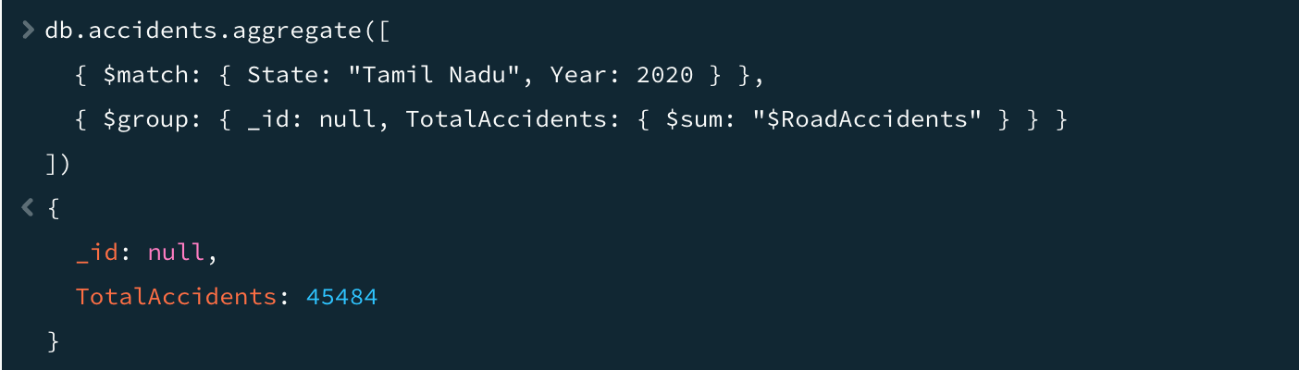
5) Get accident count for Karnataka state across all years.
Command:
mongosh
use road_accident_analysis
db.accidents.aggregate([
{ $match: { State: "Karnataka" } },
{ $group: { _id: "$Year", totalAccidents: { $sum: "$RoadAccidents" } } },
{ $sort: { _id: 1 } }
])
exit
Output:
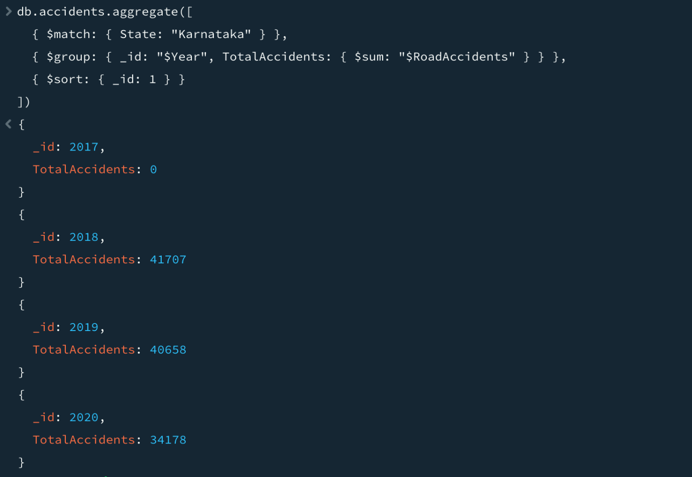

6) Calculate the 3-year (2018-2020) average and total of road accidents for each state. Display the top 20 states with the highest average road accidents in year 2018-2020 in descending order.
Command:
mongosh
use road_accident_analysis
db.accidents.aggregate([
{ $match: { Year: { $in: [2018, 2019, 2020] } } },
{ $group: {
_id: "$State",
AvgRoadAccidents: { $avg: "$RoadAccidents" },
TotalRoadAccidents: { $sum: "$RoadAccidents" }
} },
{ $sort: { AvgRoadAccidents: -1 } },
{ $limit: 20 }
])
exit
Output:
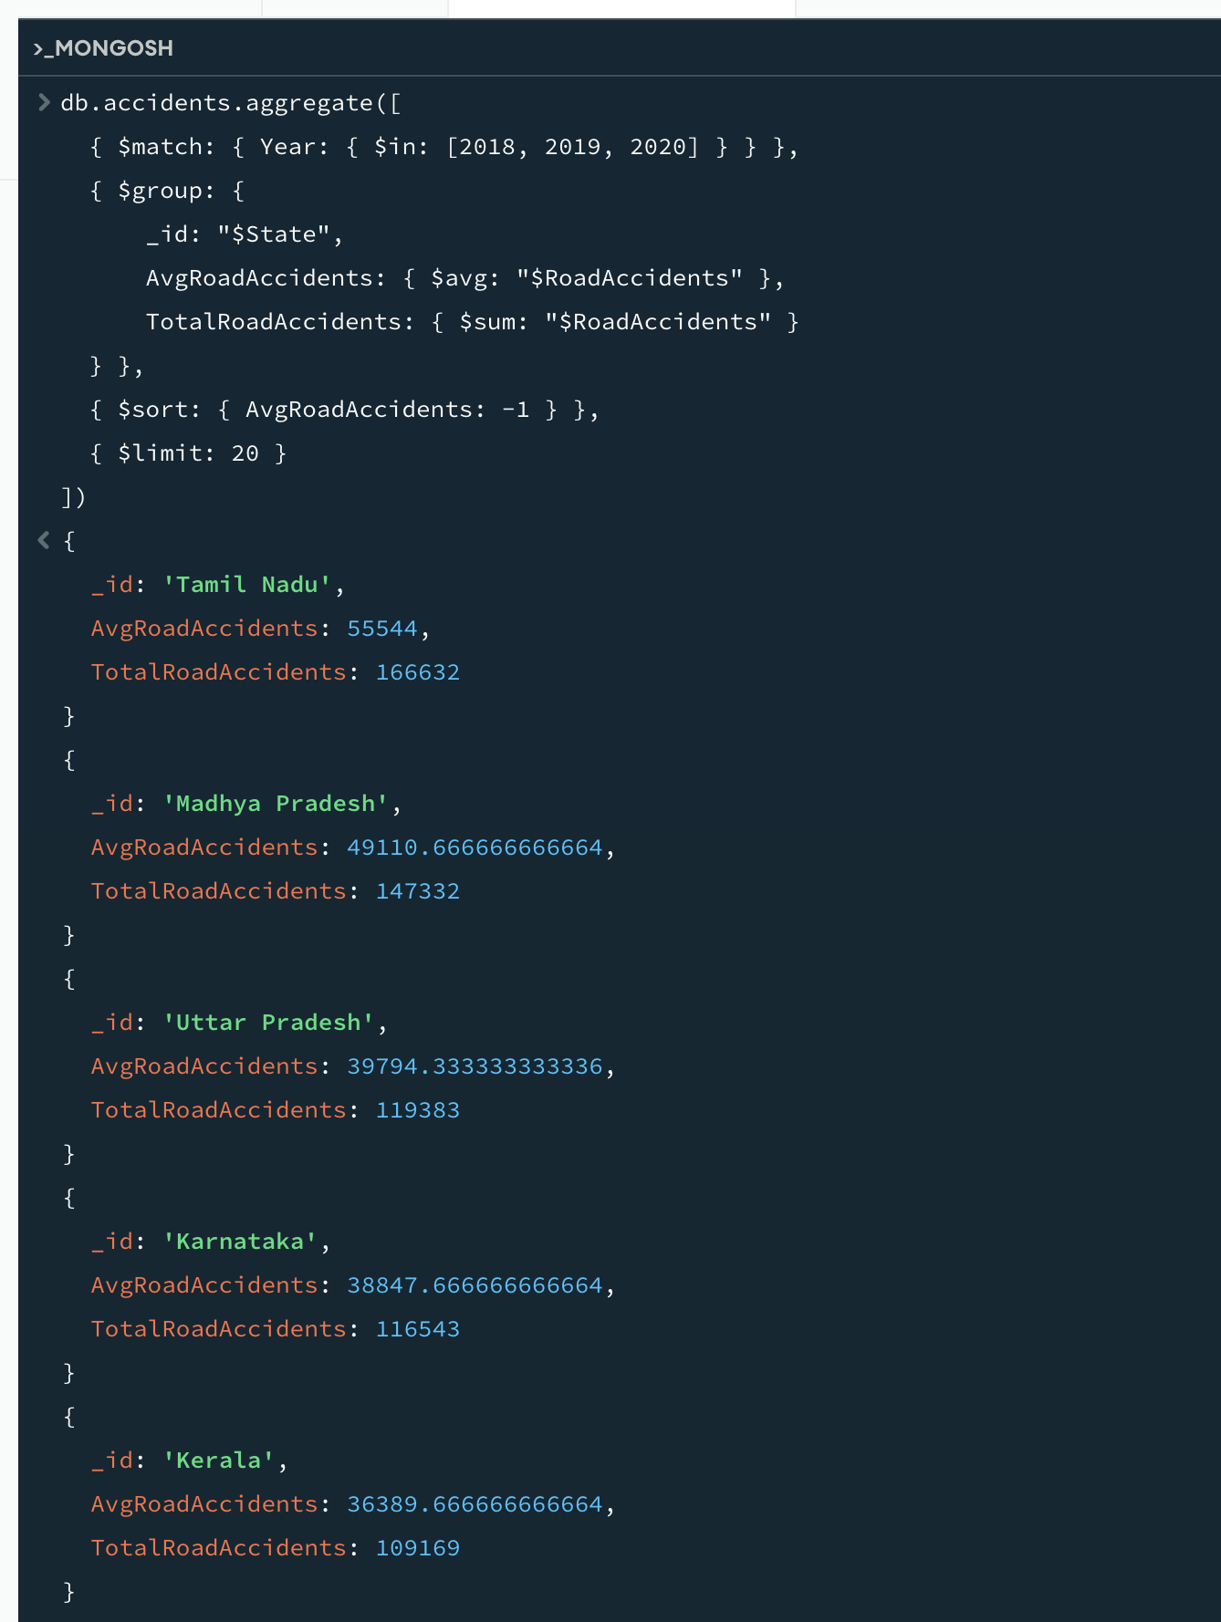
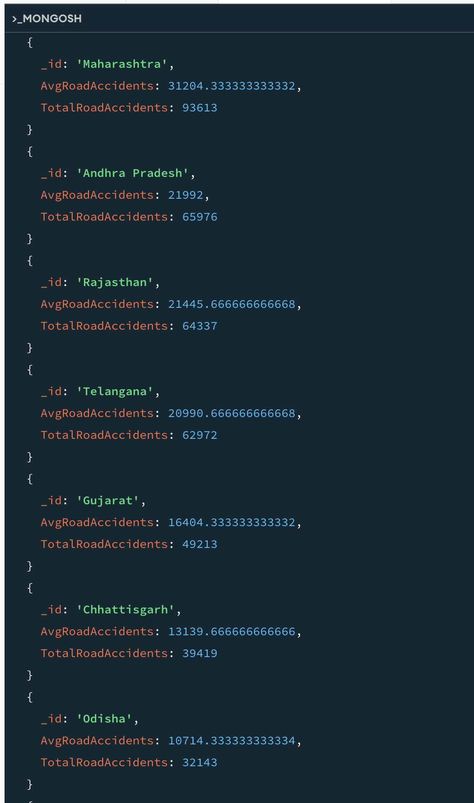
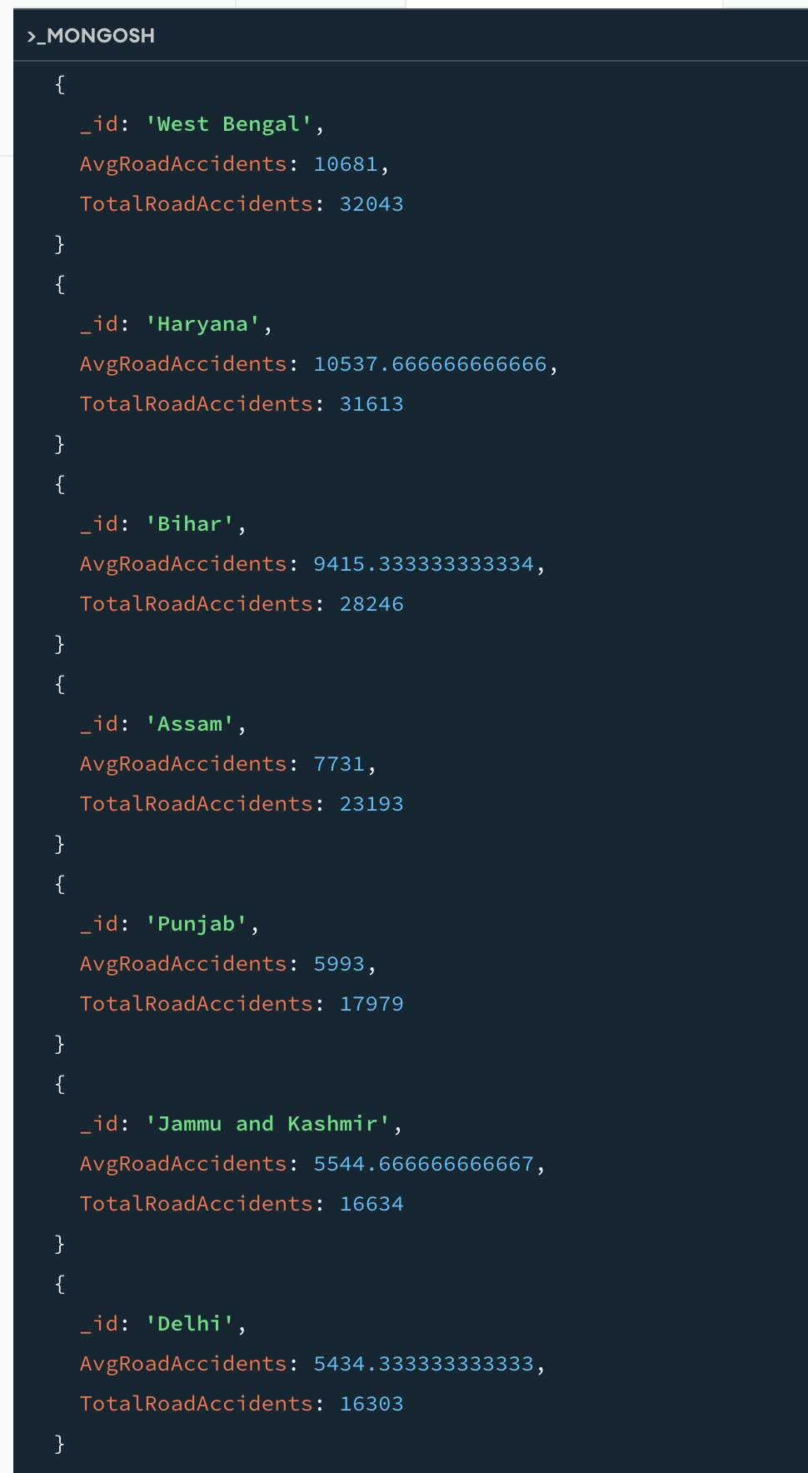
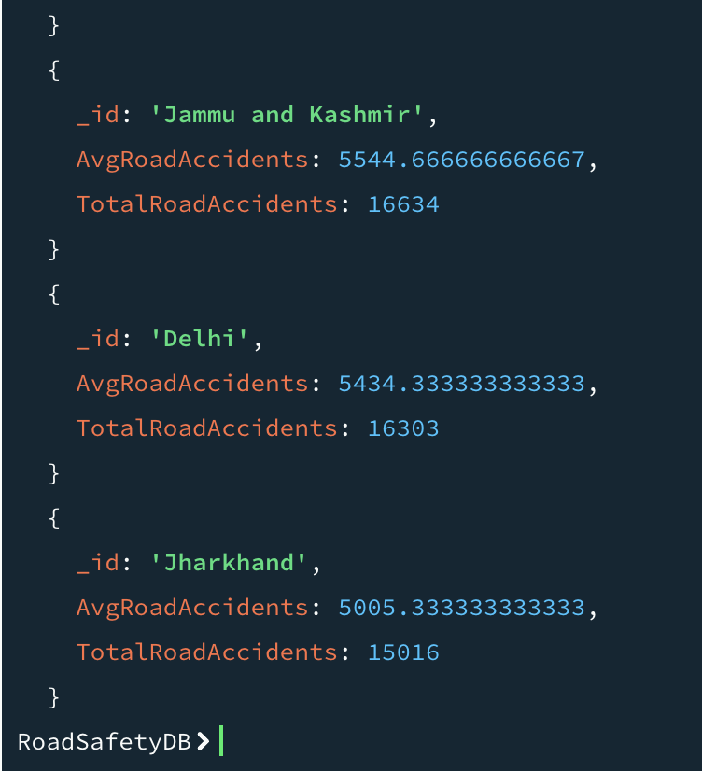

7) Rank states by their average accident fatality rate (deaths per accident) for the entire period. Display 20 states with highest fatality rate.
Command:
mongosh
use road_accident_analysis
db.accidents.aggregate([
{ $addFields: {
// Safely convert PersonsKilled to a number, treating errors and nulls as 0
Killed: {
$convert: {
input: "$PersonsKilled",
to: "int",
onError: 0, // Treat parsing errors (like empty string ' ') as 0
onNull: 0 // Treat null values as 0
}
},
// Safely convert RoadAccidents to a number, treating errors and nulls as 0
Accidents: {
$convert: {
input: "$RoadAccidents",
to: "int",
onError: 0,
onNull: 0
}
}
} },
{ $addFields: {
FatalityRate: {
$cond: {
if: { $ne: ["$Accidents", 0] },
then: { $divide: ["$Killed", "$Accidents"] },
else: 0
}
}
} },
{ $group: {
_id: "$State",
AvgFatalityRate: { $avg: "$FatalityRate" }
} },
{ $sort: { AvgFatalityRate: -1 } },
{ $limit: 20 }
])
exit
Output:
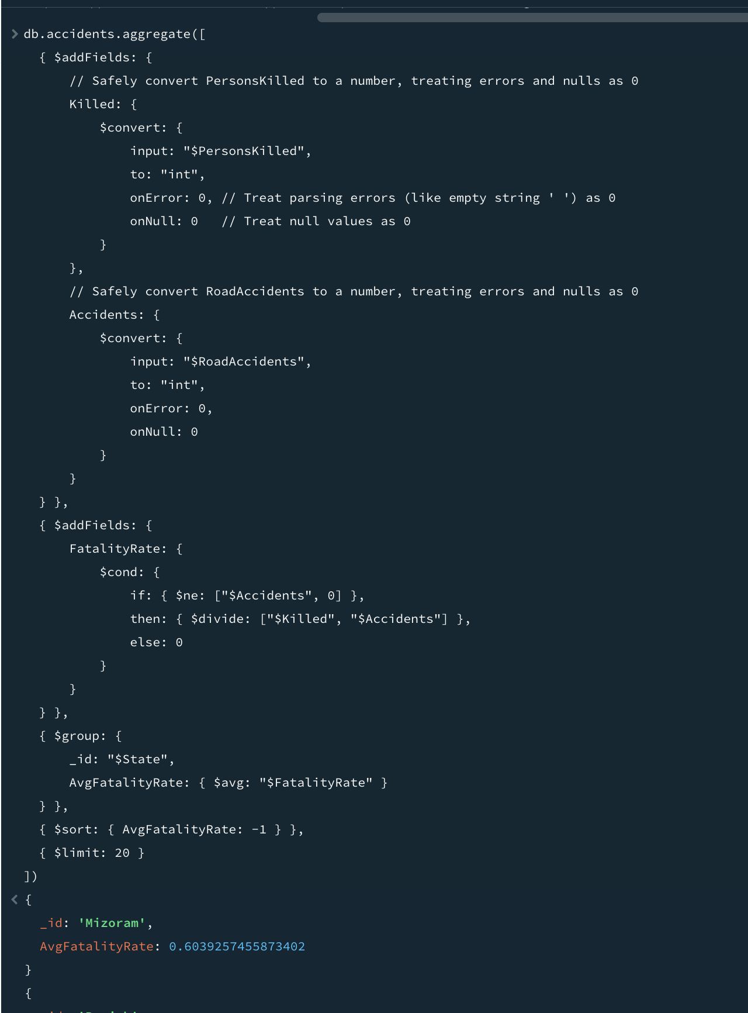
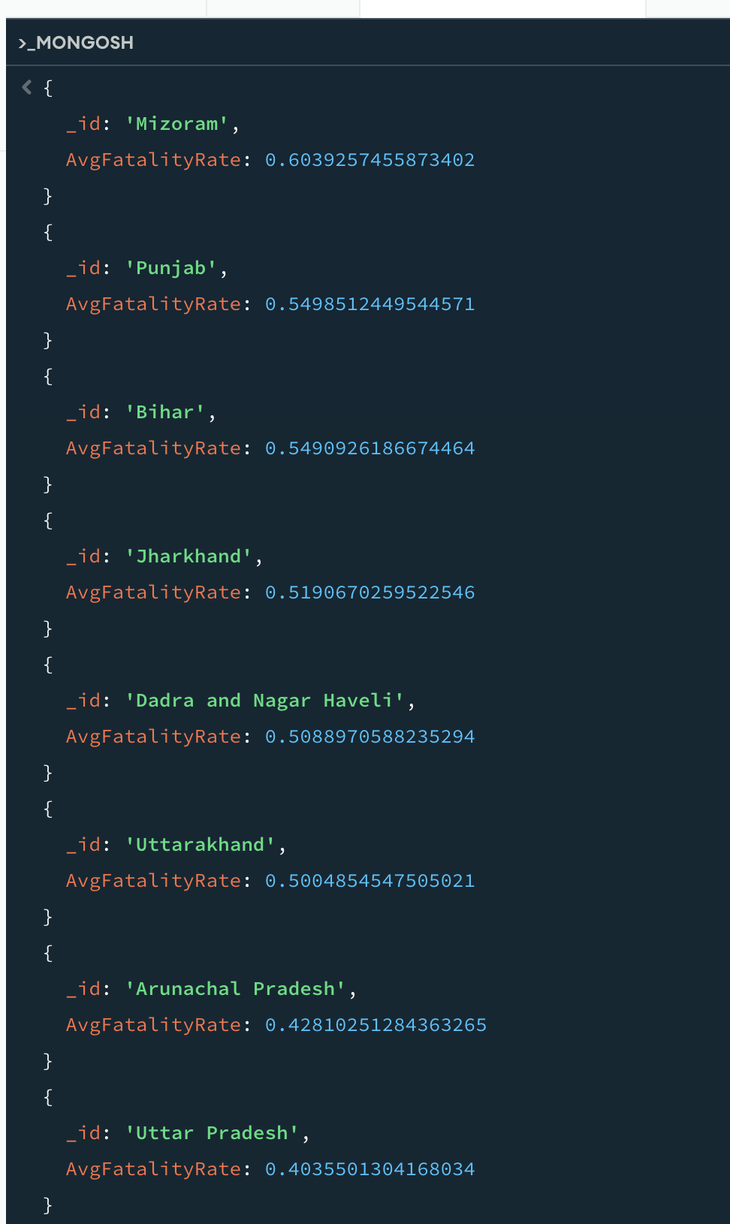
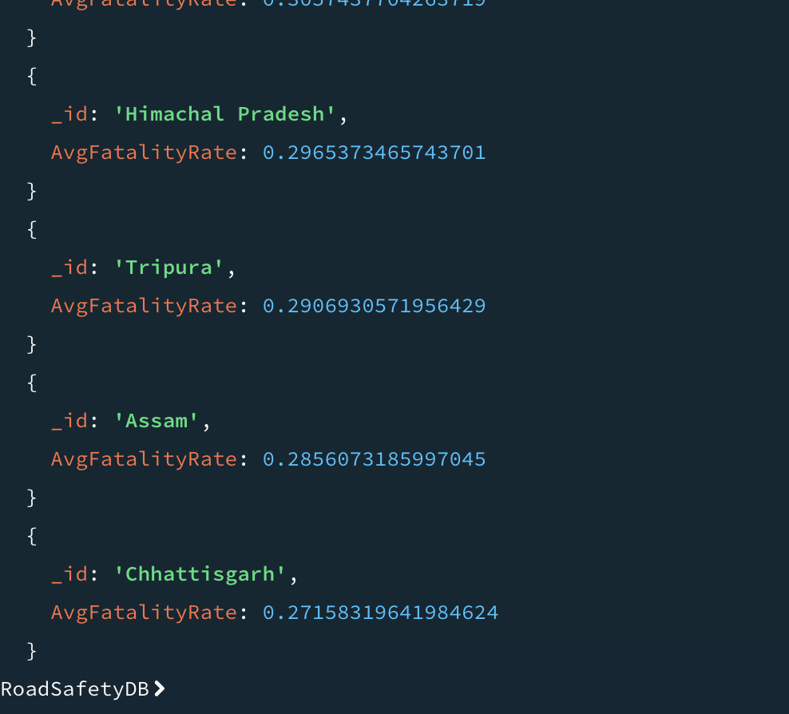

8) Calculate total accidents per state for the year 2020.
Command:
mongosh
use road_accident_analysis
db.accidents.aggregate([
{ $match: { Year: 2020 } },
{ $group: { _id: "$State", TotalAccidents2020: { $sum: "$RoadAccidents" } } },
{ $sort: { TotalAccidents2020: -1 } }
])
exit
Output:
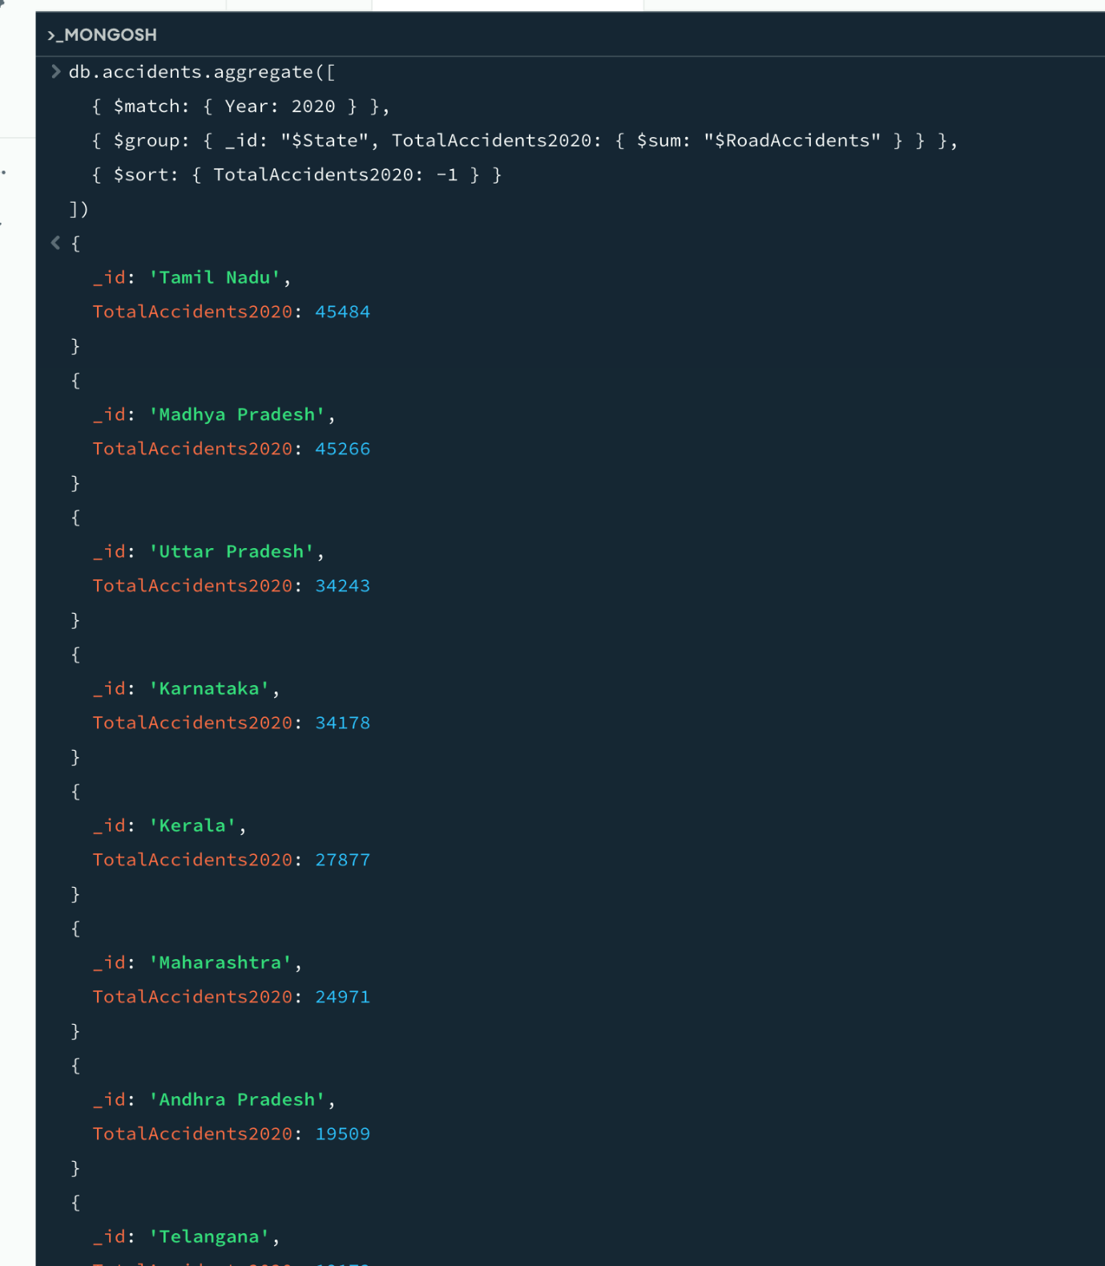
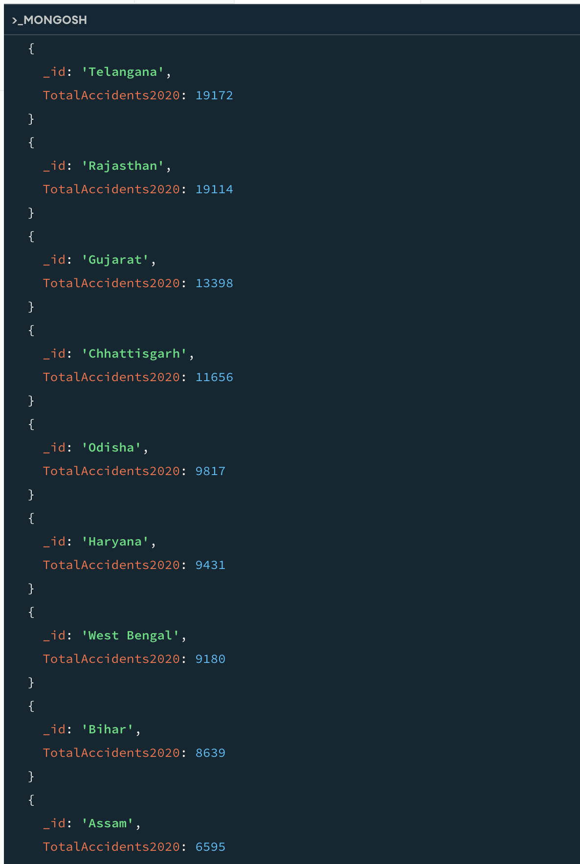

9) Compare accident counts between 2018-2020 for all states. Give only first 20 results.
Command:
mongosh
use road_accident_analysis
db.accidents.aggregate([
{ $match: { Year: { $in: [2018, 2019, 2020] } } },
{ $group: {
_id: "$State",
AccidentCounts: {
$push: {
year: "$Year",
accidents: "$RoadAccidents"
}
}
} },
{ $sort: { _id: 1 } },
{ $limit: 20 }
])
exit
Output:
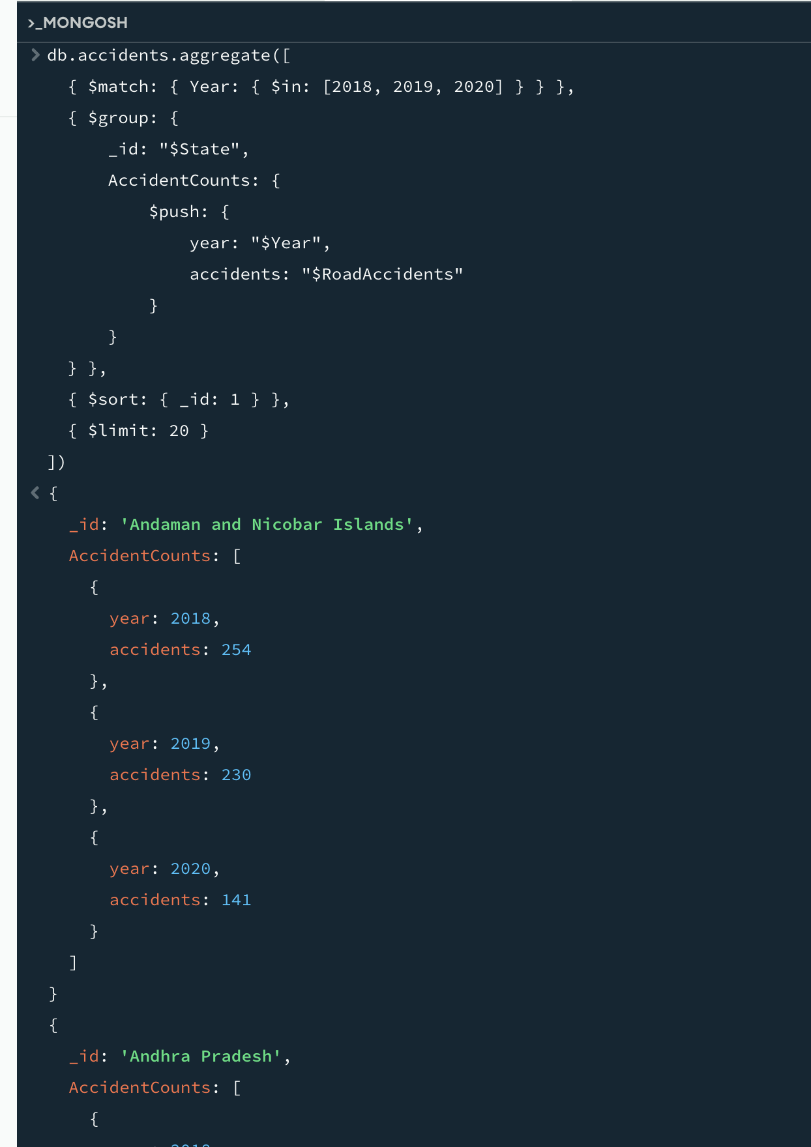
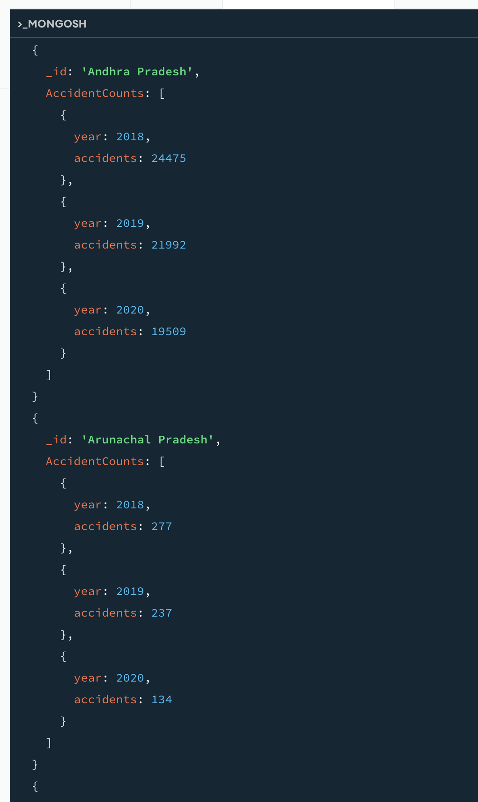
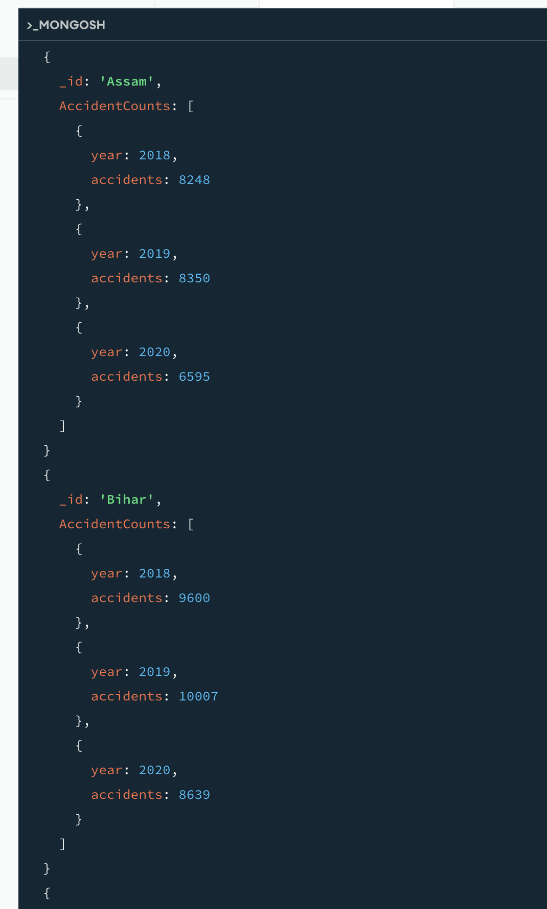
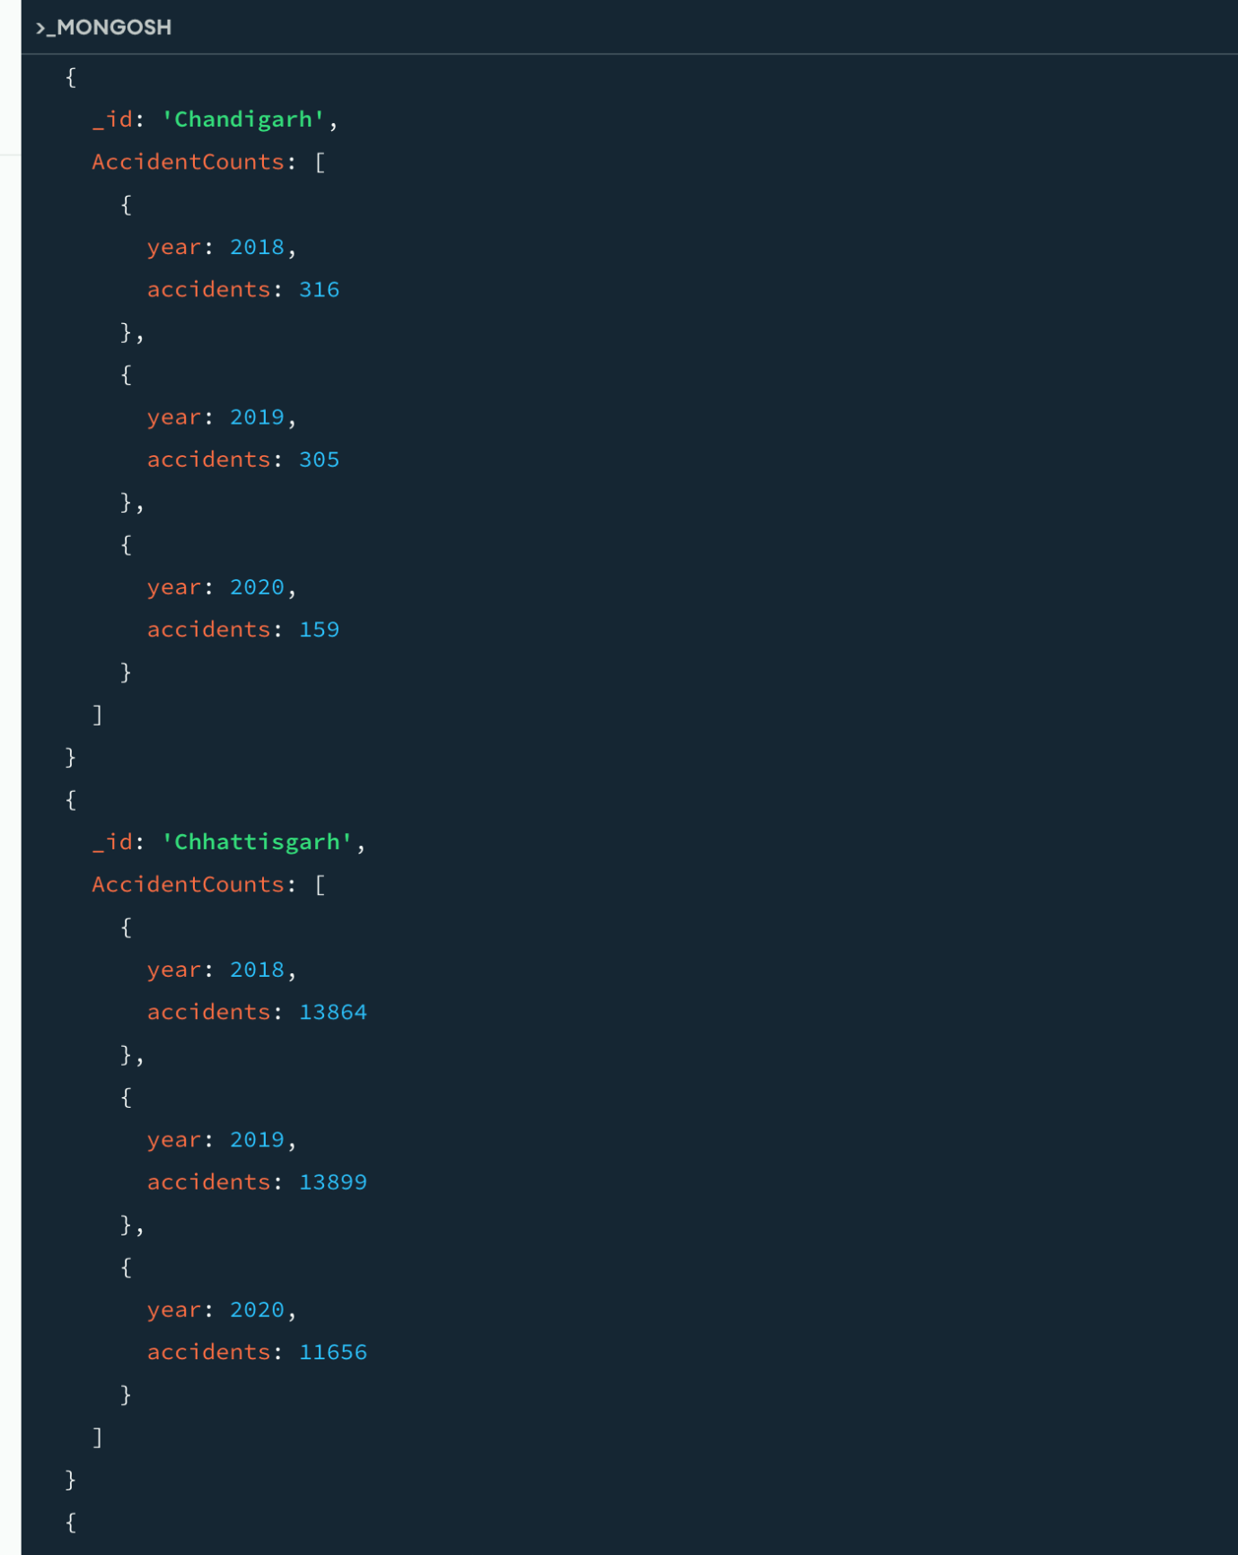
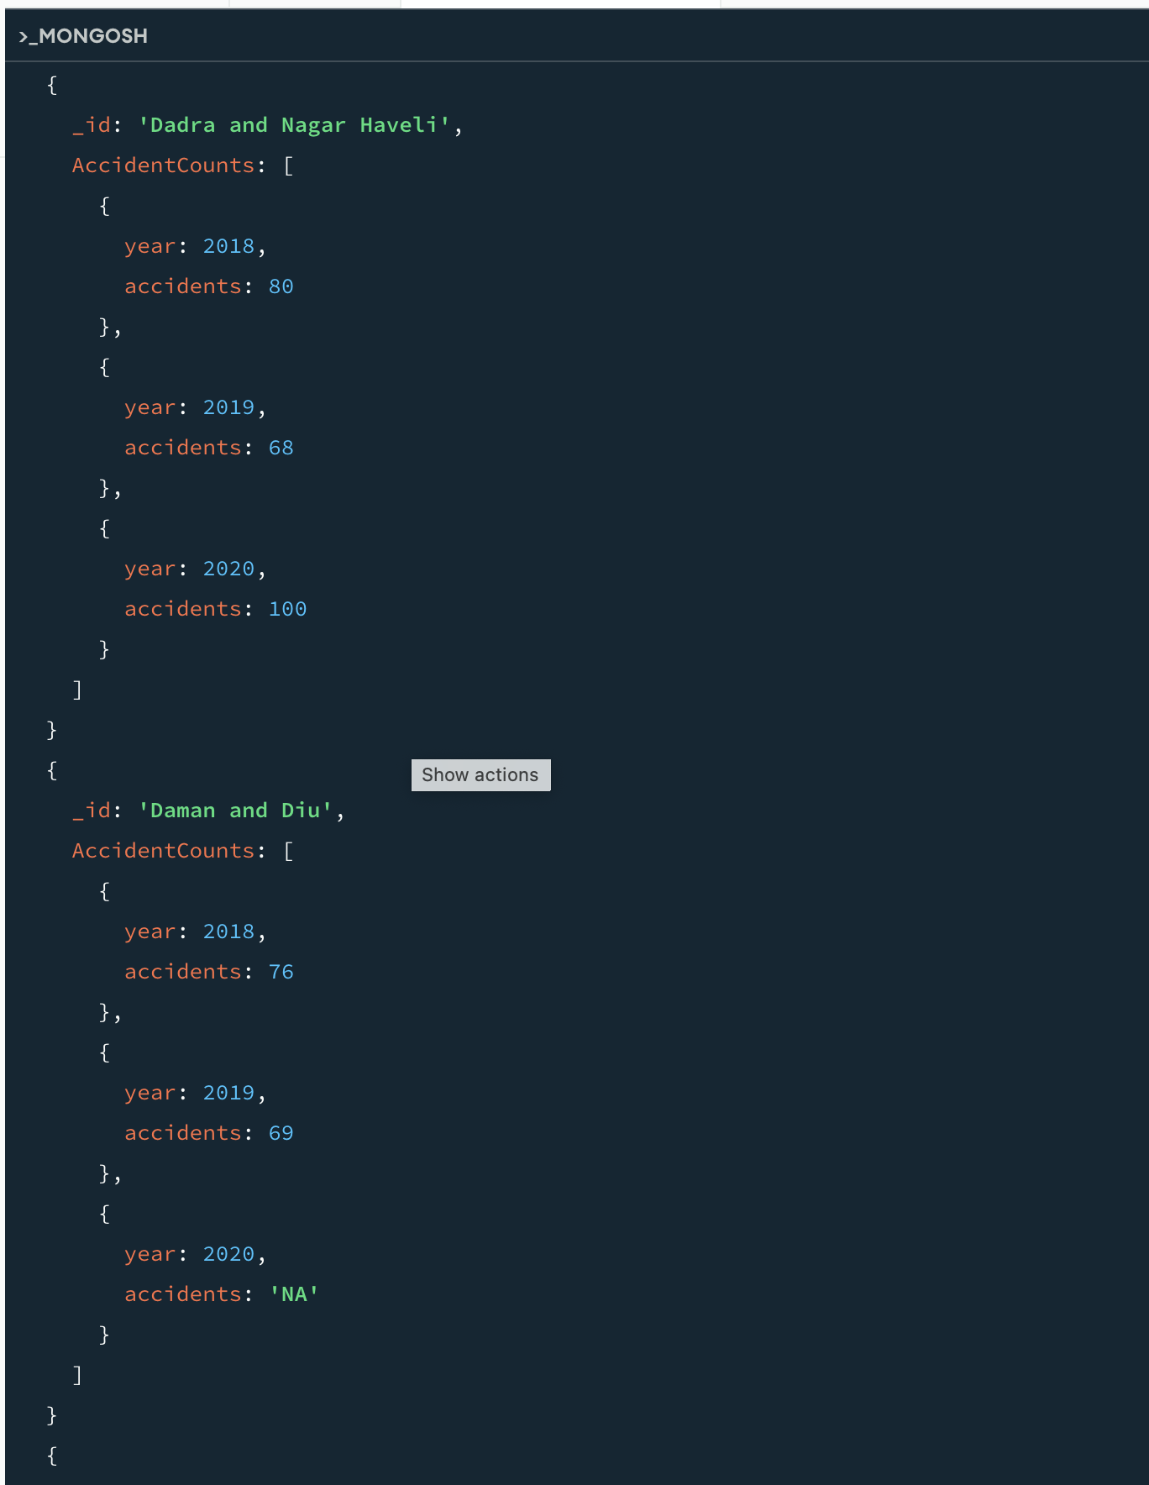
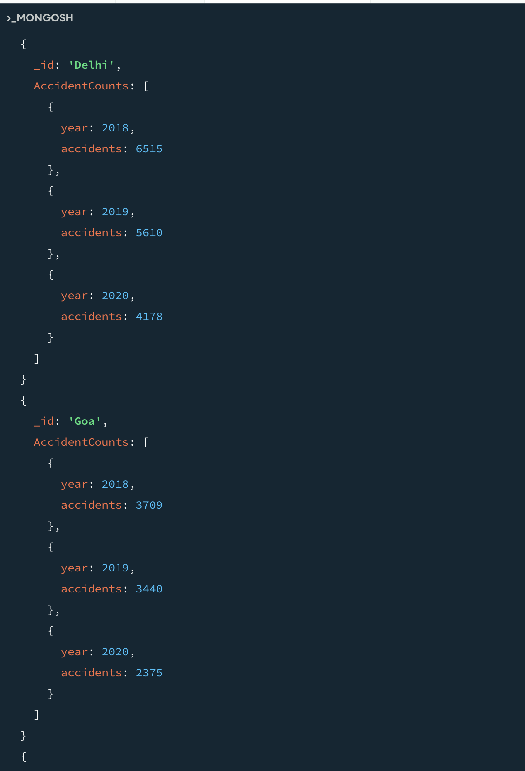
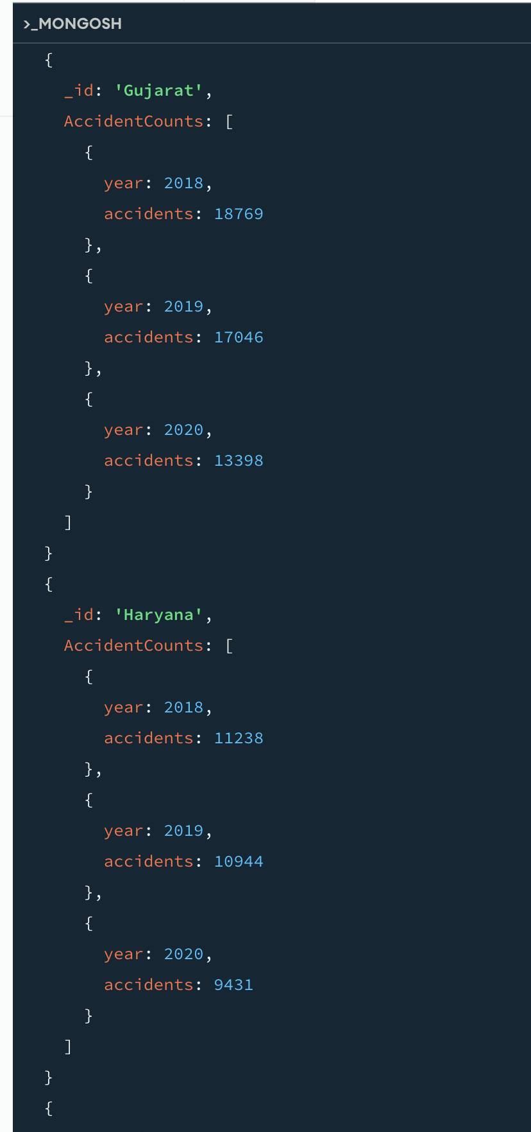
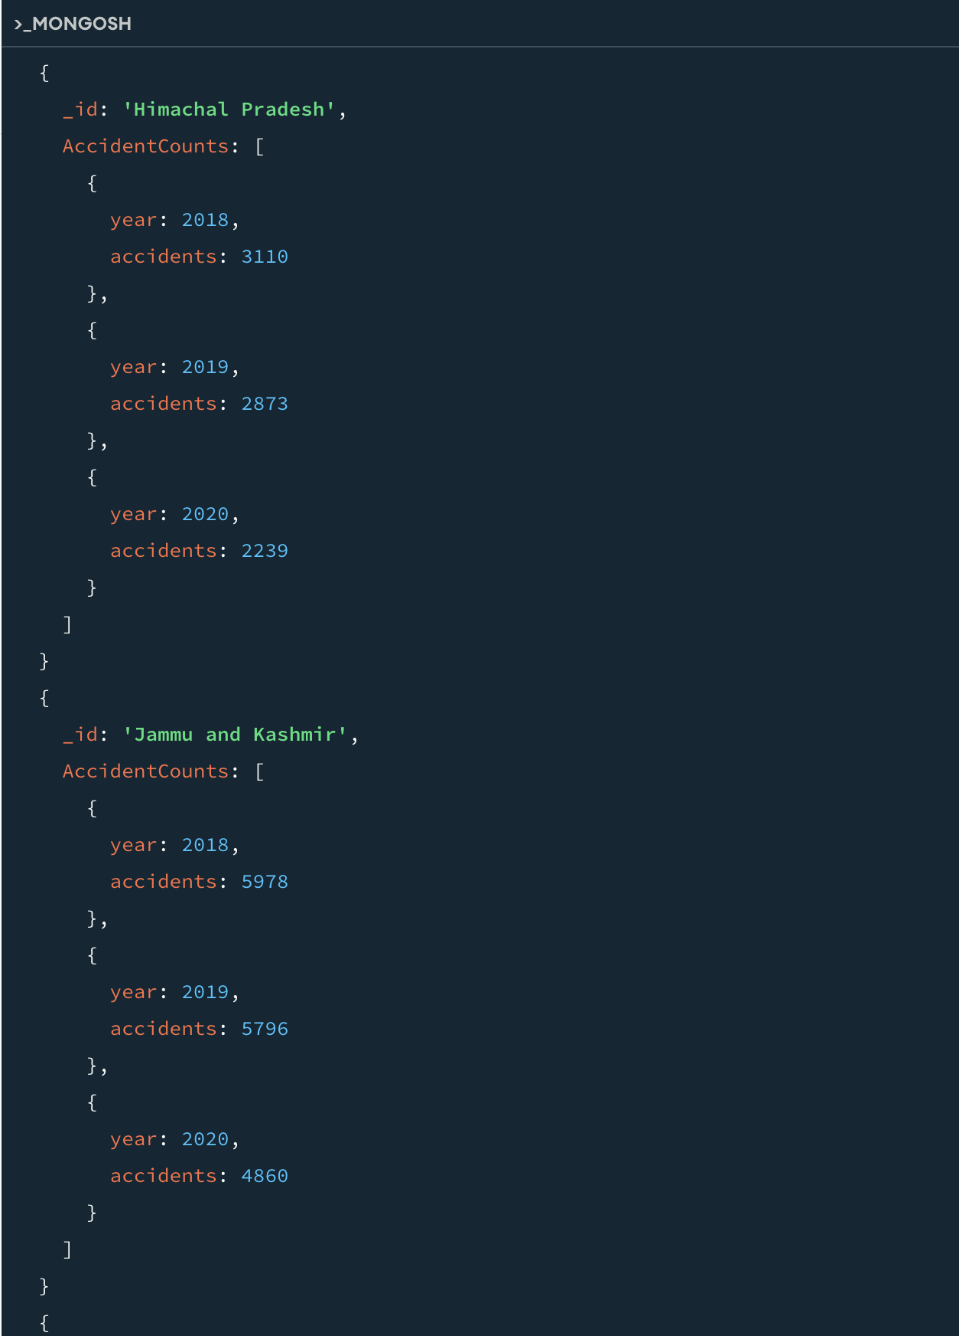
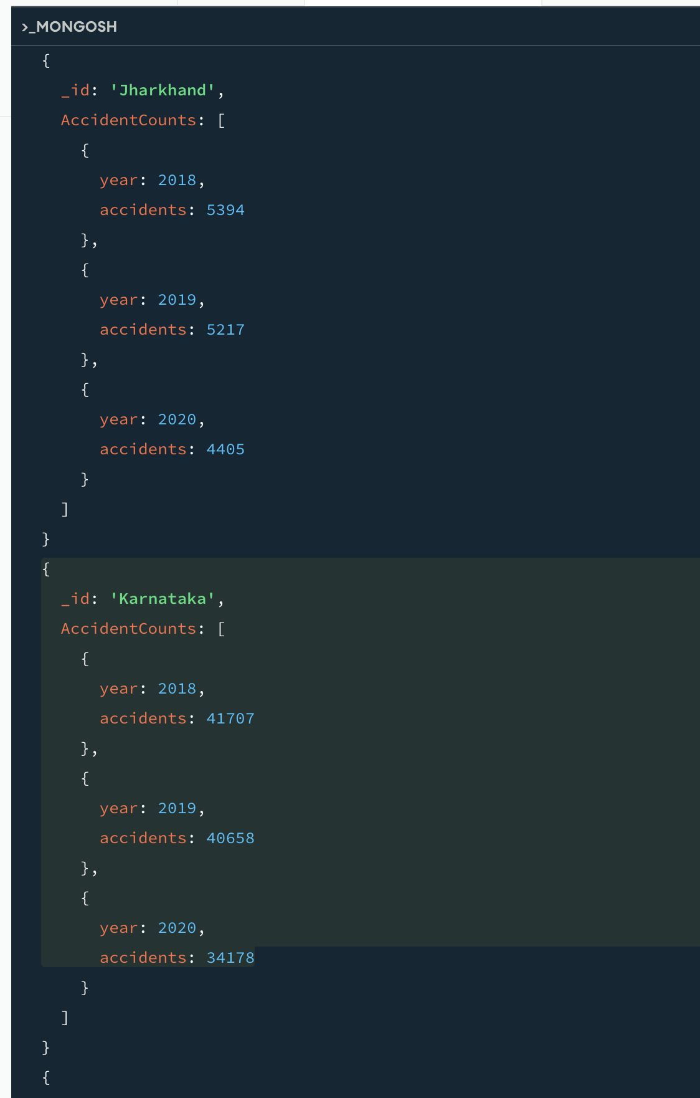
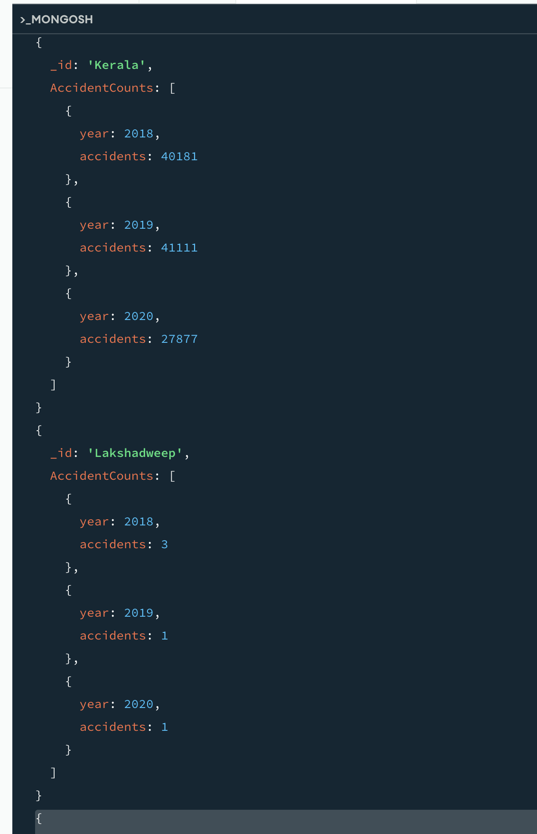
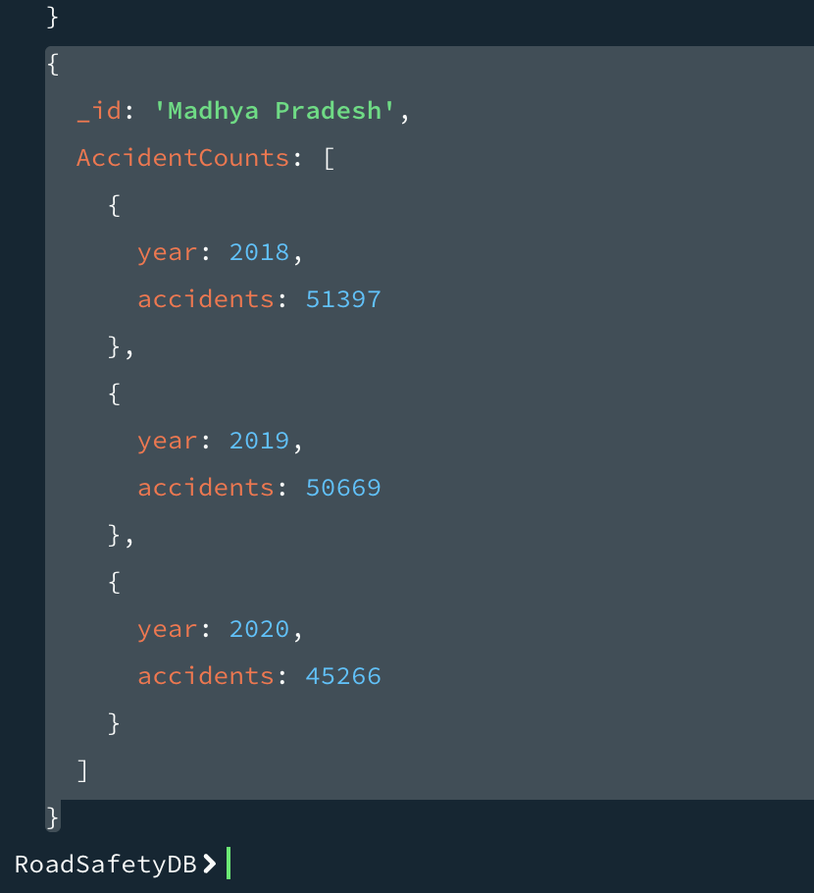

10) Find 10 states with highest accident severity ratio (persons killed per accident) in 2019?
Command:
mongosh
use road_accident_analysis
db.accidents.aggregate([
{ $match: { Year: 2019 } },
{ $addFields: {
SeverityRatio: {
$cond: {
if: { $ne: ["$RoadAccidents", 0] },
then: { $divide: ["$PersonsKilled", "$RoadAccidents"] },
else: 0
}
}
} },
{ $sort: { SeverityRatio: -1 } },
{ $limit: 10 },
{ $project: { _id: 0, State: 1, SeverityRatio: 1 } }
])
exit
Output:
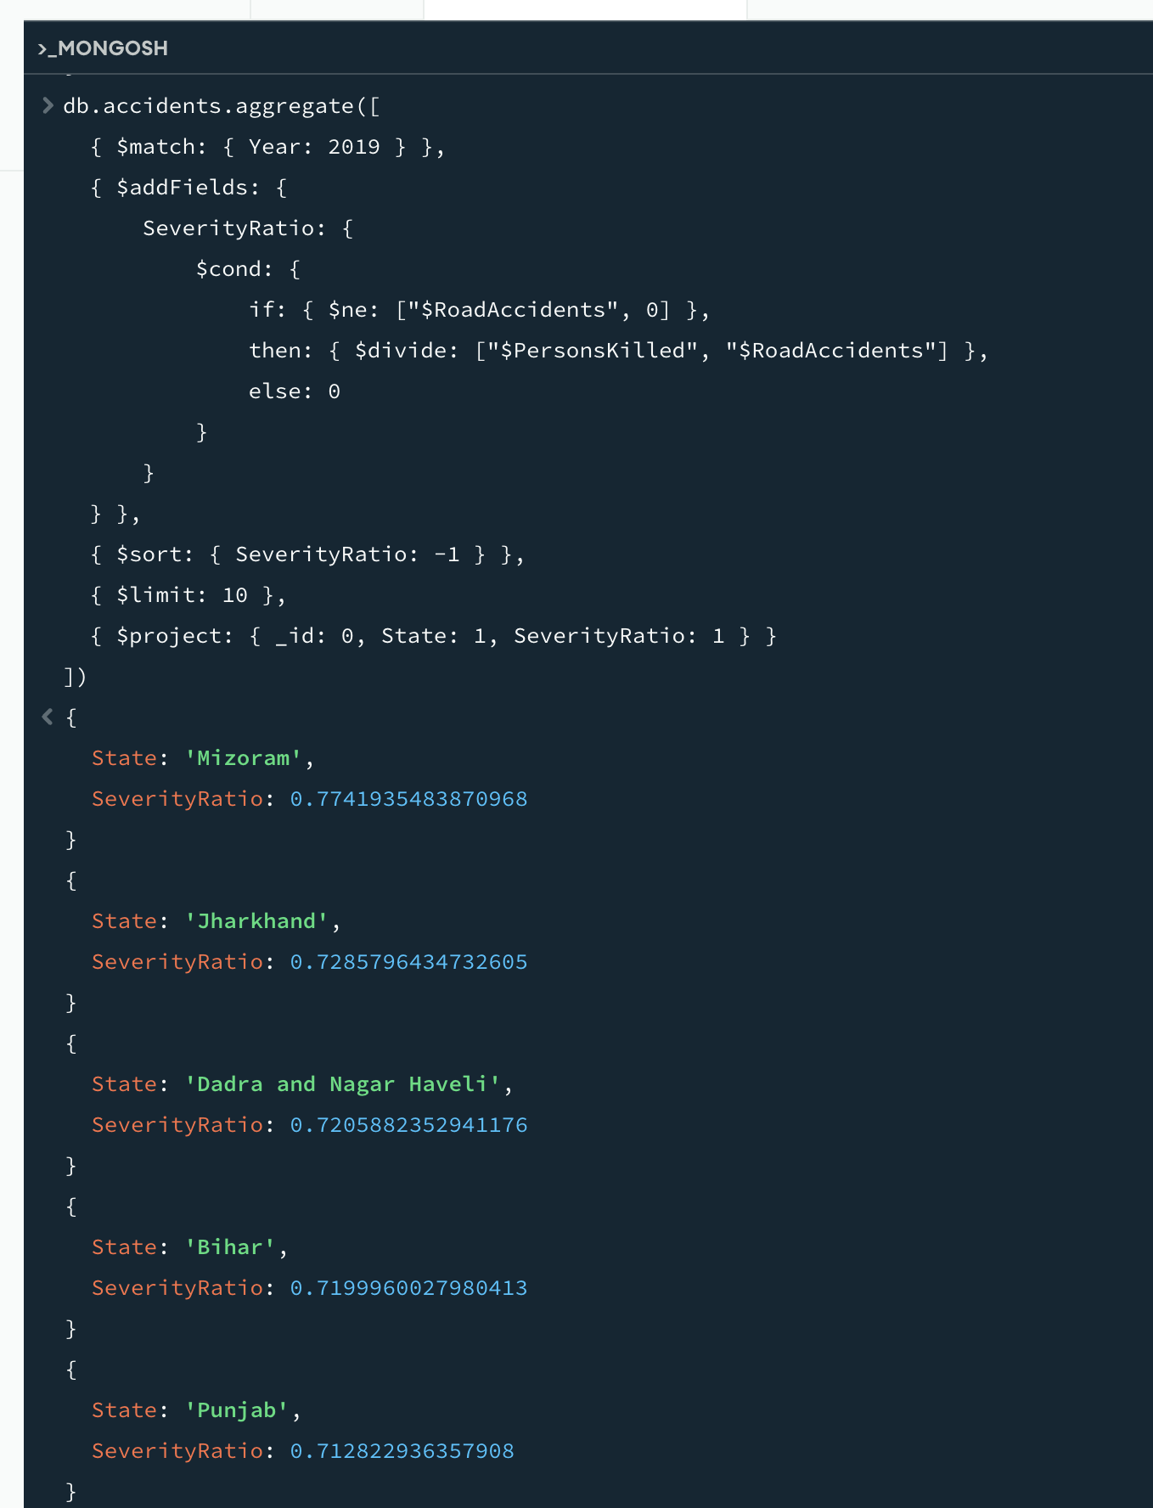

11) Find 10 states with lowest injury ratio (persons injured per accident) in 2019?
Command:
mongosh
use road_accident_analysis
db.accidents.aggregate([
{ $match: { Year: 2019 } },
{ $addFields: {
InjuryRatio: {
$cond: {
if: { $ne: ["$RoadAccidents", 0] },
then: { $divide: ["$PersonsInjured", "$RoadAccidents"] },
else: 0
}
}
} },
{ $sort: { InjuryRatio: 1 } },
{ $limit: 10 },
{ $project: { _id: 0, State: 1, InjuryRatio: 1 } }
])
exit
Output:
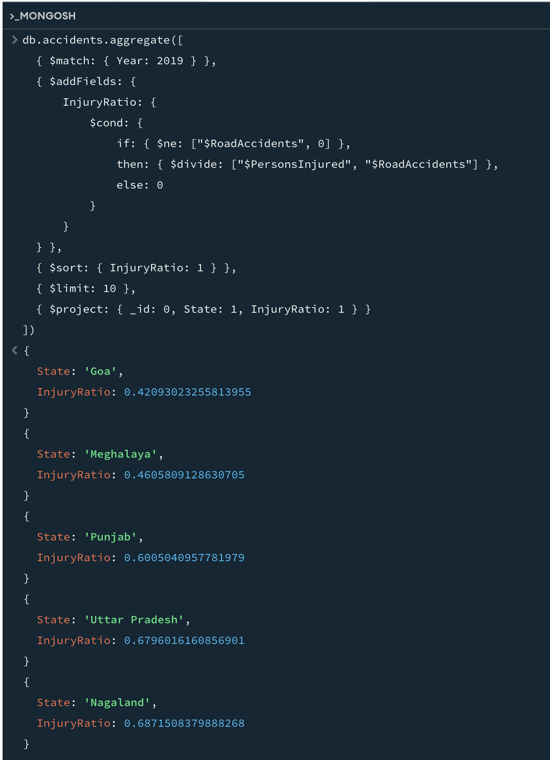

12) What are the benefits of using MapReduce computing paradigm on a MongoDB collection? Write a MapReduce shell program in Mongo shell to find out the total number of persons injured in each state. Which field will be taken as the key and which field will be taken as the value. Output the results in alphabetically sorted order by the name of the state.
Command:
Output:

